10.Perform a 90-degree rotation clockwise along the y-axis for the given image.

**AIM:**

To rotate a given image by **90 degrees clockwise along the Y-axis** using OpenCV in Python.

**PROCEDURE:**

1. Load the Image: Read the input image using OpenCV.
2. Define the Rotation Matrix: Use the appropriate transformation matrix for a 3D rotation along the Y-axis.
3. Apply Perspective Transformation: Use cv2.warpPerspective() to apply the transformation.
4. Display and Save the Output Image: Show the rotated image and save it if needed.

**PROGRAM:**

import cv2

# Load the image

img = cv2.imread("input.jpg")

# Rotate 90 degrees clockwise

rotated_img = cv2.rotate(img, cv2.ROTATE_90_CLOCKWISE)

# Display the rotated image

cv2.imshow("Rotated Image", rotated_img)

cv2.waitKey(0)

cv2.destroyAllWindows()

**INPUT:**

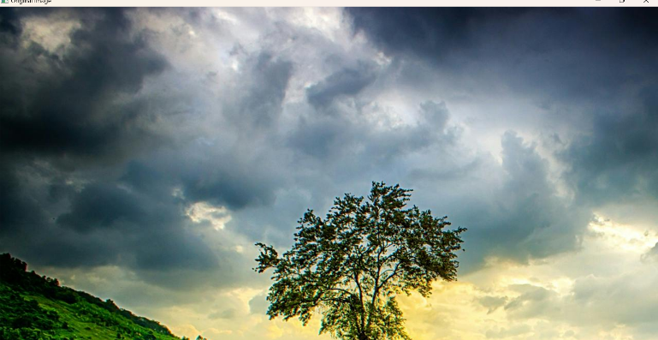

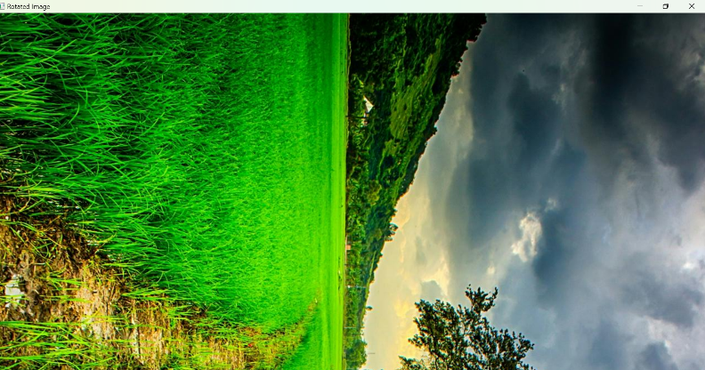

**OUTPUT:**

**RESULT :**

Successfully applied a **90-degree rotation along the Y-axis**, achieving a **3D perspective transformation** in OpenCV.